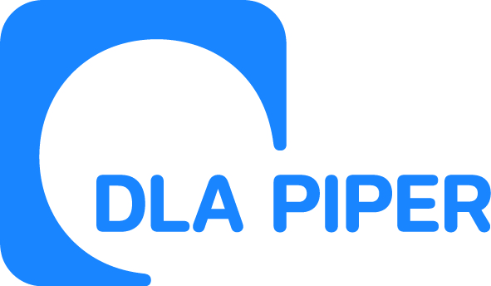

**NEWS RELEASE**

**DLA PIPER TEAMS UP WITH TOKENY TO PROVIDE COMPANIES WITH A BLOCKCHAIN SOLUTION TO OFFERING SECURITIES ON A GLOBAL BASIS**

DLA Piper has teamed up with the compliant tokenization platform, Tokeny, to provide an approach to capital raising which enables companies to raise funding in a regulatory compliant manner from their own website. The initiative, called 'The Digital Securities Alliance', is a sophisticated off-the-shelf tool which links corporate issuers with investors through blockchain technology.

This offering brings together the use of advanced blockchain technology with DLA Piper's global network of offices to provide low cost solutions for small and large cap businesses that wish to raise capital, or tokenise traditional equity or debt capital whilst complying with global securities regulations. The Alliance covers the regulatory framework and the relevant Know Your Customer and anti-money laundering requirements for securities in various jurisdictions.

Issuers will be able to access this innovative service at any time of the day and from any location around the world. The tool enables multijurisdictional offers to sophisticated investors in a cost efficient manner.

DLA Piper's international group head of Finance & Projects and international co-head of the Blockchain and Digital Assets practice, Martin Bartlam, said: "Technology is now providing tremendous opportunities for law firms to improve the way we offer professional services to clients. This is increasingly relevant in providing cost efficient cross-border solutions to small and large cap businesses looking to access capital to develop their business offering. Working with a technology provider to structure a compliant legal offering is a great way to open up capital markets and enable businesses to access capital in a low cost and efficient way."

Tokeny CEO Luc Falempin said: "For the digital securities ecosystem to develop it is essential for institutional investors to commit significant capital. By establishing this unique relationship with one of the world’s leading law firms, we are creating the right infrastructure and opening up a tremendous opportunity for institutional involvement. Institutions can finally invest in digital assets knowing the offering gives effect to and is compliant with the necessary regulations. The Digital Securities Alliance resembles this best of both worlds approach, as it is one thing to know what laws to respect but it’s another actually enforcing those rules on the blockchain. There is a growing awareness amongst traditional financial players that blockchain technology will transform the infrastructure in capital markets. Of course, those that come from a distributed ledger technology background have believed this for a long time, but we’re now seeing traditional players sharing the same opinion. This partnership is a manifestation of that shared belief."

**ENDS**

**Notes to editors:**

1. DLA Piper is a global law firm with lawyers located in more than 40 countries throughout the Americas, Asia Pacific, Europe, Africa and the Middle East, positioning it to help companies with their legal needs anywhere in the world.
2. For further information about our organisation and services, please visit our website: www.dlapiper.com